Skill-1
Battapothula Guru Sai
2520090075

Encapsulation Builder: Analyze the overhead introduced by protocol headers and determine how encapsulation affects network efficiency.

Aim: To capture network packets and understand how Ethernet, IP, and TCP/UDP headers are added during data transmission.

Whenever data travels through a computer network, each protocol layer adds its own header to the data. These headers introduce overhead. Using Wireshark, we will capture real network packets, examine Ethernet, IP and TCP/UDP headers, calculate the total overhead, and determine how efficiently the network carries application data.

Interface after connecting too a wifi

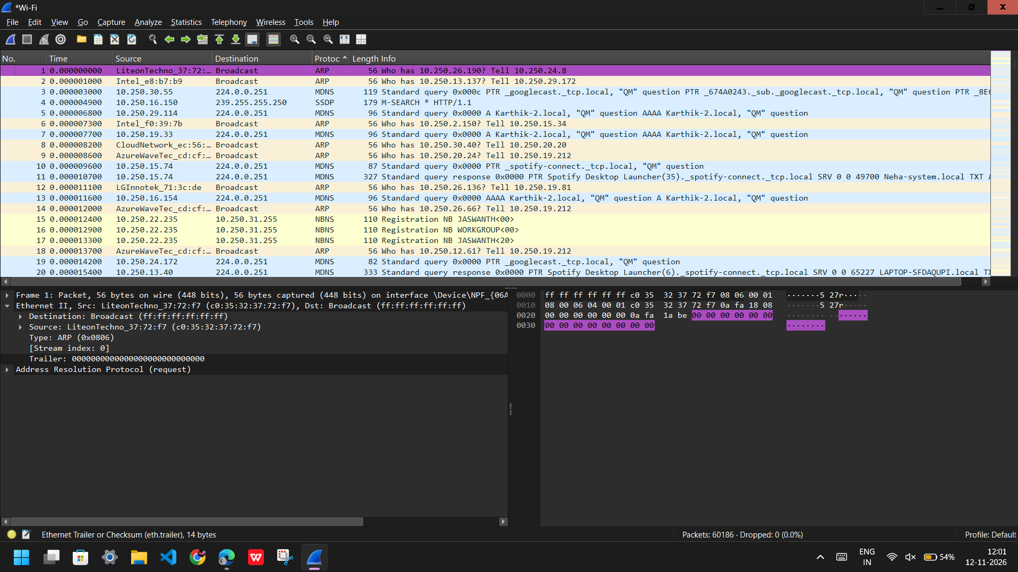

Interface after computing tcp filter
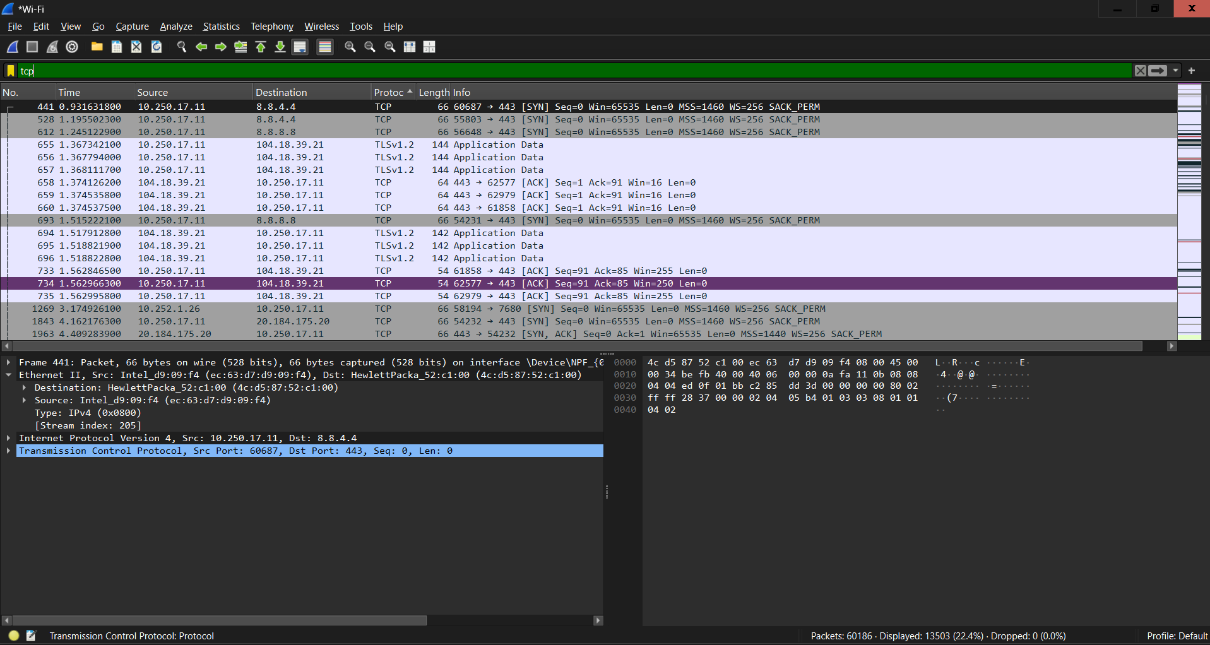

Interface after computing udp filter
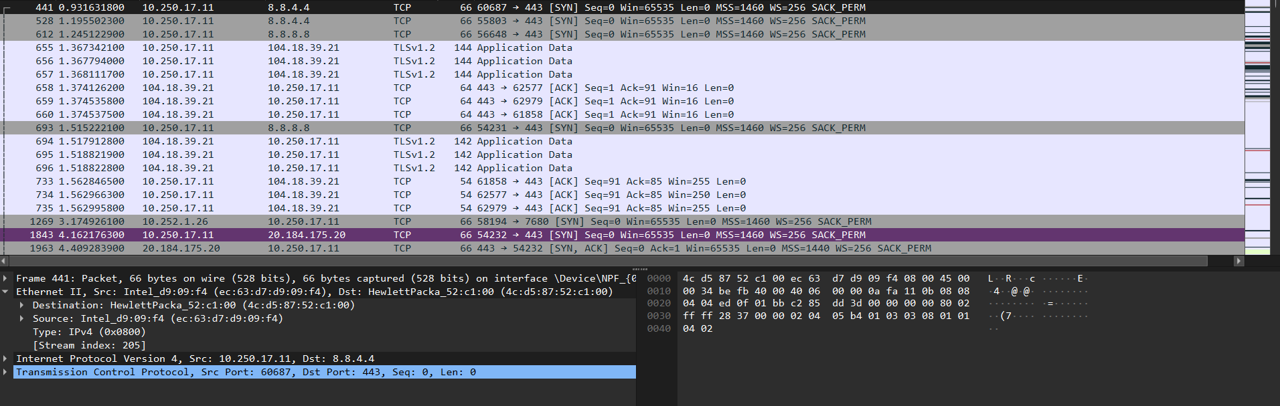

tcp.len > 0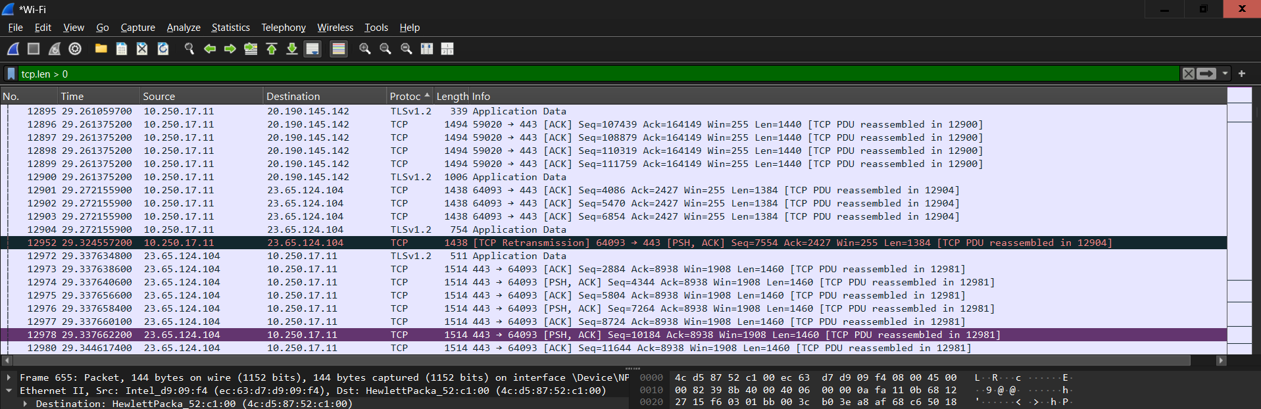
Values for a tcp filter
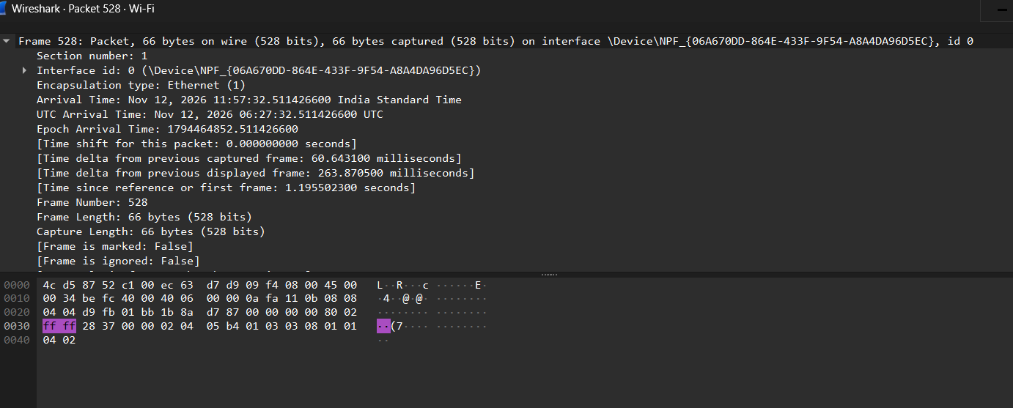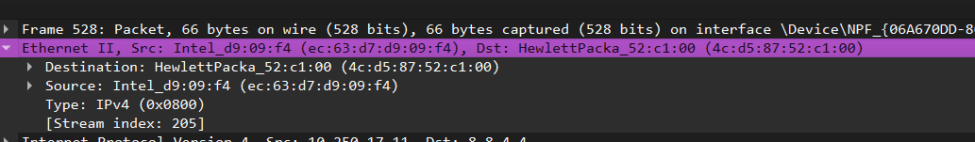

Values for a dcp filter
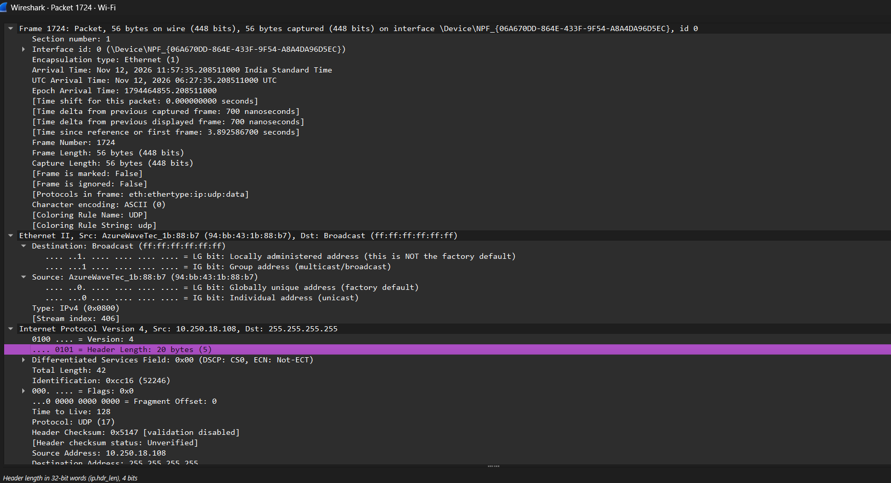

Calculations

TCP Packet Observation
Parameter | Observed value
Frame number | 528
Frame length | 66 bytes
Ethernet II header | 14 bytes
IPv4 header length | 20 bytes
IPv4 total length | 52 bytes
TCP header length | 32 bytes
TCP segment length | 32 bytes
TCP payload length | 0 bytes
FCS | Not included in the captured frame length shown

3. UDP Packet Observation
Parameter | Illustrative UDP value
Frame length | 60 bytes (sample)
Ethernet II header | 14 bytes (standard Ethernet II)
IPv4 header length | 20 bytes (sample IPv4 header without options)
IPv4 total length | 46 bytes (sample)
UDP header length | 8 bytes (standard UDP header)
UDP length | 26 bytes (sample; UDP header + data)
UDP payload length | 18 bytes (sample)
FCS | Not included in the assumed captured frame length

4. Detailed Calculations

A. TCP packet calculations (actual screenshot values)
1) IPv4 payload = IPv4 Total Length − IPv4 Header Length = 52 − 20 = 32 bytes.
2) TCP application payload = TCP Segment Length − TCP Header Length = 32 − 32 = 0 bytes.
3) Total headers = Ethernet Header + IPv4 Header + TCP Header = 14 + 20 + 32 = 66 bytes.
4) Frame length check = Ethernet Header + IPv4 Total Length = 14 + 52 = 66 bytes. This matches the displayed frame length.
5) Header overhead percentage = (Total header bytes ÷ Frame length) × 100 = (66 ÷ 66) × 100 = 100%.
6) Payload efficiency = (Application payload ÷ Frame length) × 100 = (0 ÷ 66) × 100 = 0%.
Interpretation: this selected TCP packet carries no application data; it is a control/connection packet. The 0% efficiency applies only to this individual packet, not to the whole network.

B. UDP packet calculations (illustrative sample values)
1) UDP payload = UDP Length − UDP Header Length = 26 − 8 = 18 bytes.
2) IPv4 payload = IPv4 Total Length − IPv4 Header Length = 46 − 20 = 26 bytes. This equals the UDP Length.
3) Total headers = Ethernet Header + IPv4 Header + UDP Header = 14 + 20 + 8 = 42 bytes.
4) Frame length check = Ethernet Header + IPv4 Total Length = 14 + 46 = 60 bytes. This matches the assumed sample frame length.
5) Header overhead percentage = (Total header bytes ÷ Frame length) × 100 = (42 ÷ 60) × 100 = 70%.
6) Payload efficiency = (UDP application payload ÷ Frame length) × 100 = (18 ÷ 60) × 100 = 30%.
Note: these calculations exclude the 4-byte Ethernet FCS because it is not included in the assumed captured frame length. If a capture explicitly includes FCS, add 4 bytes to the frame-size and overhead calculations.

5. Combined Observation Table
Parameter | TCP | UDP
Frame length | 66 bytes (actual) | 60 bytes (illustrative)
Ethernet header length | 14 bytes | 14 bytes
IP header length | 20 bytes | 20 bytes (illustrative)
Transport header length | 32 bytes | 8 bytes
IP total length | 52 bytes | 46 bytes (illustrative)
Transport length | 32 bytes TCP segment | 26 bytes UDP length (illustrative)
Application payload length | 0 bytes | 18 bytes (illustrative)
Header overhead | 66 bytes | 42 bytes (illustrative)
Header overhead percentage | 100% | 70% (illustrative)
Payload efficiency | 0% | 30% (illustrative)

Conclusion
In this experiment, Wireshark was used to capture and analyze network packets to understand protocol encapsulation and header overhead.
The captured TCP packet (Frame Number 528) had a total frame length of 66 bytes. The Ethernet header occupied 14 bytes, the IPv4 header occupied 20 bytes, and the TCP header occupied 32 bytes. The packet contained zero bytes of application payload because it was a TCP control packet.
The experiment demonstrated that each network layer adds its own header information during encapsulation. These headers are necessary for addressing, routing, error checking and reliable communication.
Thus, Wireshark helped us understand packet structure, protocol headers, encapsulation and the effect of header overhead on network efficiency.

